**Georges Yazigi Email:** [**thisisgeorgio@gmail.com**](mailto:thisisgeorgio@gmail.com) **phone: +96179148885** [**https://www.linkedin.com/in/georges-yazigi**](https://www.linkedin.com/in/georges-yazigi)

The function of the document is to provide the description of an online grocery store that runs on a website. The document describes everything on the website and explaining each part how it works.

The website has a large database that consists of users, categories, items, orders and order details.

By using MySQL database engine, we’ve created the required database tables:

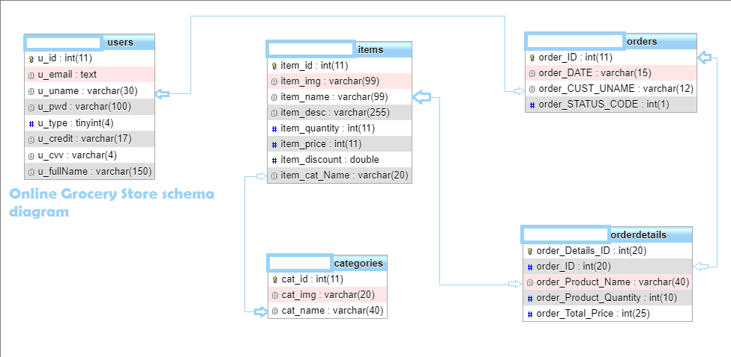

You can create the above database through the following DDL statement:

CREATE TABLE `users` (

`u_id` int(11) NOT NULL AUTO_INCREMENT,

`u_email` text NOT NULL,

`u_uname` varchar(30) NOT NULL,

`u_pwd` varchar(100) NOT NULL,

`u_type` tinyint(4) NOT NULL,

`u_credit` varchar(17) NOT NULL,

`u_cvv` varchar(4) NOT NULL,

`u_fullName` varchar(150) NOT NULL,

PRIMARY KEY (`u_id`)

) ENGINE=MyISAM AUTO_INCREMENT=48 DEFAULT CHARSET=latin1

CREATE TABLE `categories` (

`cat_id` int(11) NOT NULL AUTO_INCREMENT,

`cat_img` varchar(20) NOT NULL,

`cat_name` varchar(40) NOT NULL,

PRIMARY KEY (`cat_id`)

) ENGINE=MyISAM AUTO_INCREMENT=54 DEFAULT CHARSET=latin1

CREATE TABLE `items` (

`item_id` int(11) NOT NULL AUTO_INCREMENT,

`item_img` varchar(99) NOT NULL,

`item_name` varchar(99) NOT NULL,

`item_desc` varchar(255) NOT NULL,

`item_quantity` int(11) NOT NULL,

`item_price` int(11) NOT NULL,

`item_discount` double NOT NULL,

`item_cat_Name` varchar(20) NOT NULL,

PRIMARY KEY (`item_id`)

) ENGINE=MyISAM AUTO_INCREMENT=52 DEFAULT CHARSET=latin1

CREATE TABLE `orders` (

`order_ID` int(11) NOT NULL AUTO_INCREMENT,

`order_DATE` varchar(15) NOT NULL,

`order_CUST_UNAME` varchar(12) NOT NULL,

`order_STATUS_CODE` int(1) NOT NULL,

PRIMARY KEY (`order_ID`)

) ENGINE=MyISAM AUTO_INCREMENT=45 DEFAULT CHARSET=latin1

CREATE TABLE `orderdetails` (

`order_Details_ID` int(20) NOT NULL AUTO_INCREMENT,

`order_ID` int(20) NOT NULL,

`order_Product_Name` varchar(40) NOT NULL,

`order_Product_Quantity` int(10) NOT NULL,

`order_Total_Price` int(25) NOT NULL,

PRIMARY KEY (`order_Details_ID`)

) ENGINE=MyISAM AUTO_INCREMENT=96 DEFAULT CHARSET=latin1

After creating the required data tables for the online grocery store database

Using HTML, CSS, JavaScript (jQuery library) and PHP, I’ve created a well secured website which has the goal to keep the users data secure from unauthorized people who might access the website database.

The website that we have created has 3 types of users which are the following:

1. Administrator: the administrator is a user who has access on all the user data inside the database except their account password. This user type can add, edit and delete users, categories and items. The admin can view orders and order details for customers.
2. HR: the HR is a user who only has access to add new users or HRs but not admins.
3. Users: users are customer who can login or register a new account with all required details. Users can browse categories and items, add items to cart and edit the items inside their carts and proceed to checkout.

**The Home Page of the Grocery store looks like this:**



1. In the homepage the visitor is able to go to the categories page and find a specific item inside a category.

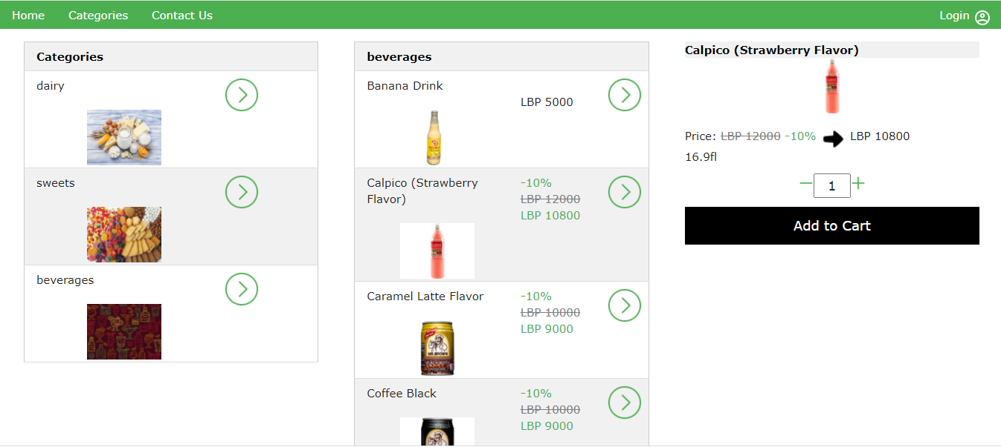

But if the visitor wants to add an item to cart the system will show an error and tells the user that “You must be logged to do this”:

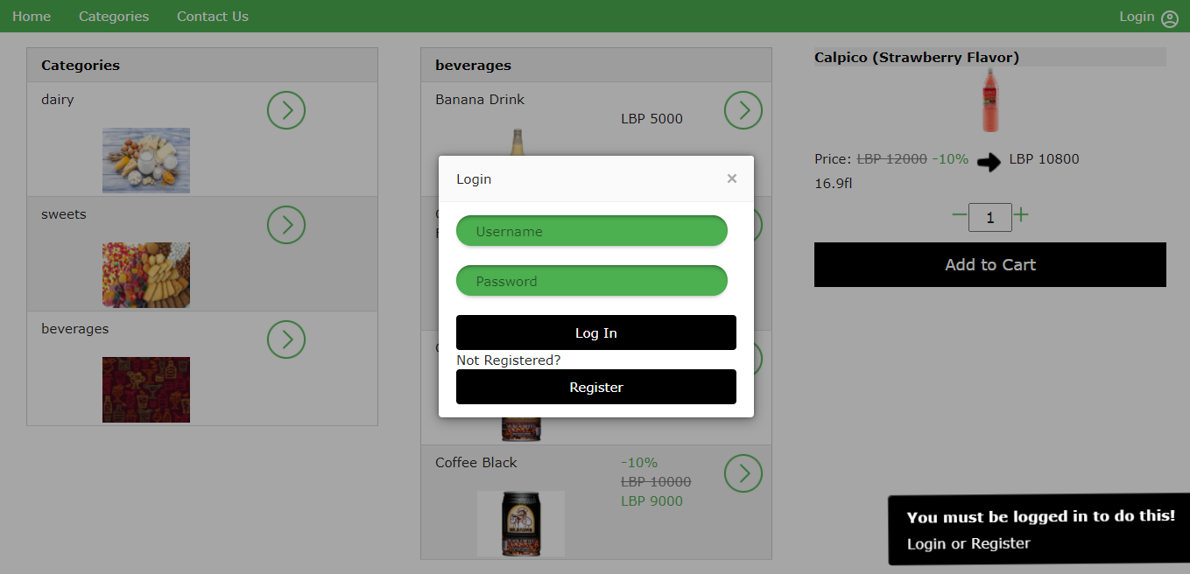

1. In the homepage the visitor is able to open a login or register modal and either login or sign up with a new account by pressing the login button on the top right corner.

Login modal:

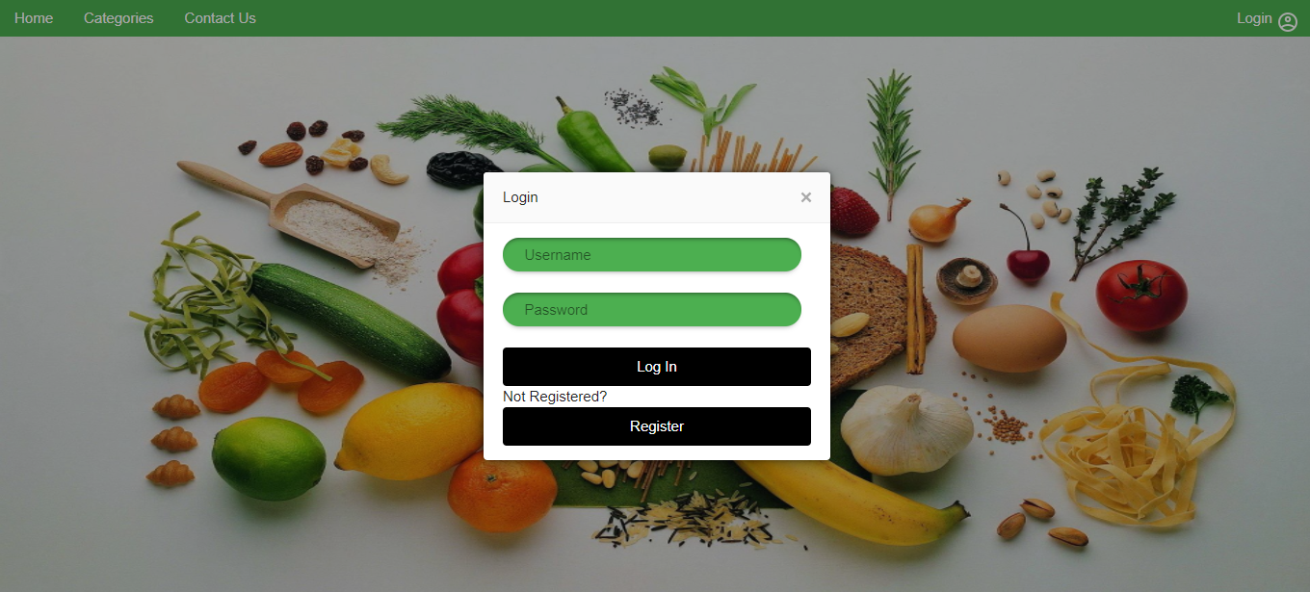

If a user already has a created account he can enter his username and password and if the credentials that was entered are correct he can sign in if not an error will be thrown telling him that he entered wrong credentials.

Sign up modal:

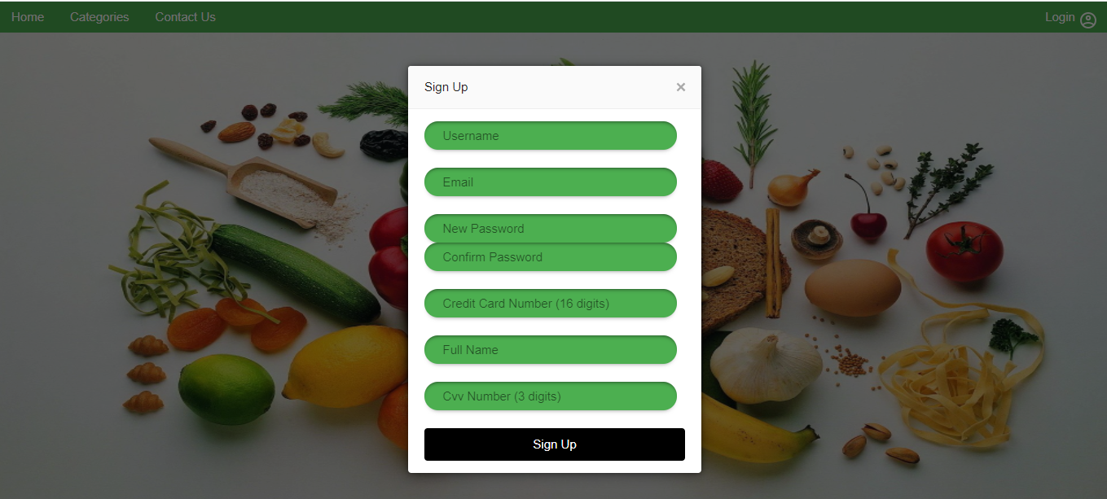

If the user is new, he must register a new username, while entering his username a function checks if the username that he entered is already inside the database, if it is then an error will be shown on the modal telling him that this username already taken please choose another one.

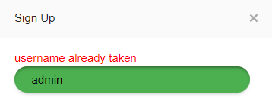

Then he must enter his email address, create a new password and confirm his password, the password should meet the information security password policy which is the following:

The password must contain at least 8 digits including one capital letter, one small letter, numbers, and at least one symbol

If the password does not match the information security password policy, when clicking the register button an error will be thrown as the following:

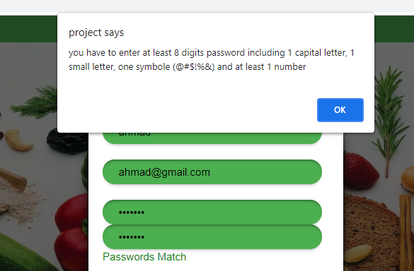

Then the new user must enter his credit card number which should be restrictively 16 numbers and his full name on the card then the CVV that should be restrictively 3 numbers if not the following error will be thrown:

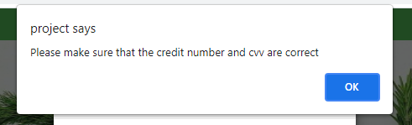

If all the required data that the new user has entered are complete and nothing is incorrect or missing, then the new user will be automatically logged into his new account and immediately the user home page will be loaded for him.

1. In the homepage a visitor can go to the contact us page and have our emails and phone numbers.

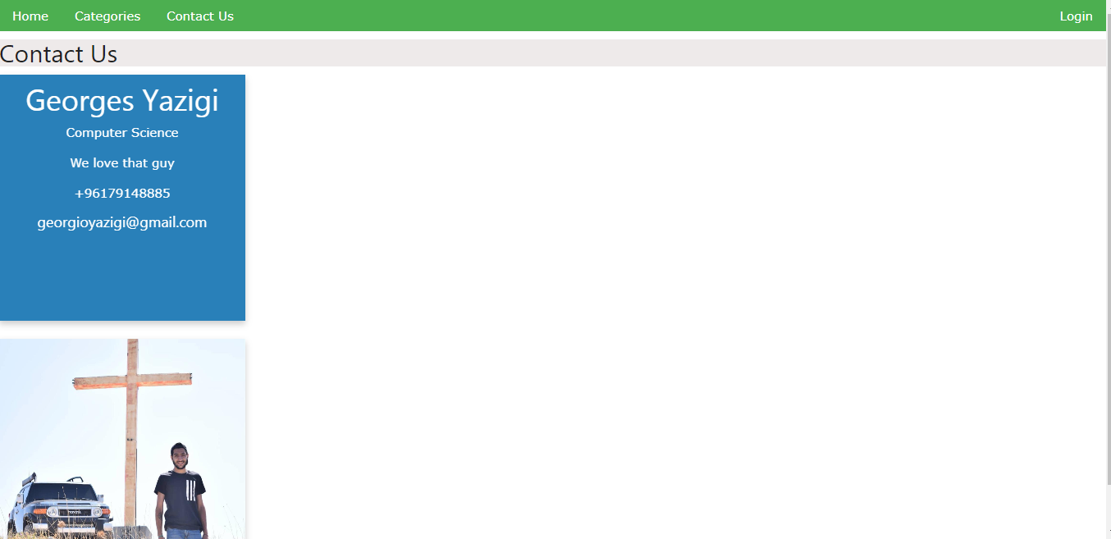

When the mouse hover over an image the image will flip and shows you our contact infos.

After successfully logging in

If the user type that logged in is an **admin** then the admin home page will appear where he can browse through the navigation the following pages:

 and 

Users page:

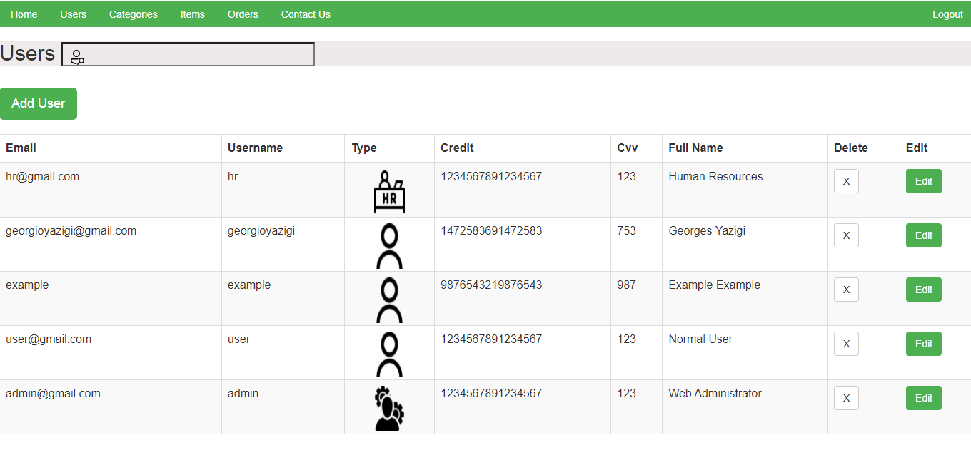

* In the users page the admin can:
* Search for a specific user by entering his username inside the search bar

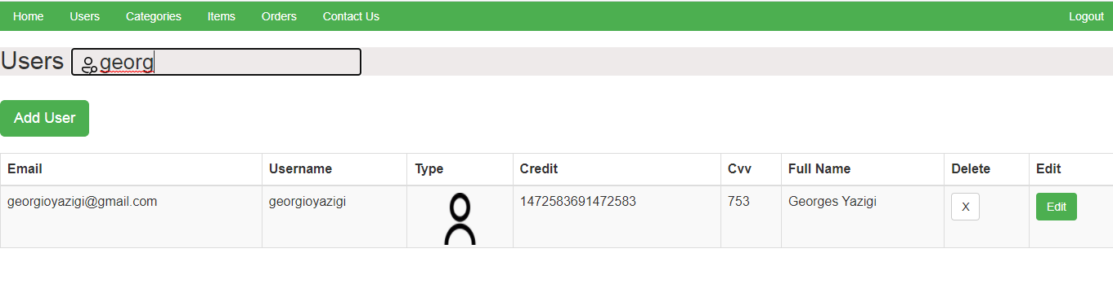

* Add users by clicking the Add User button where a modal for adding user will appear like the following:

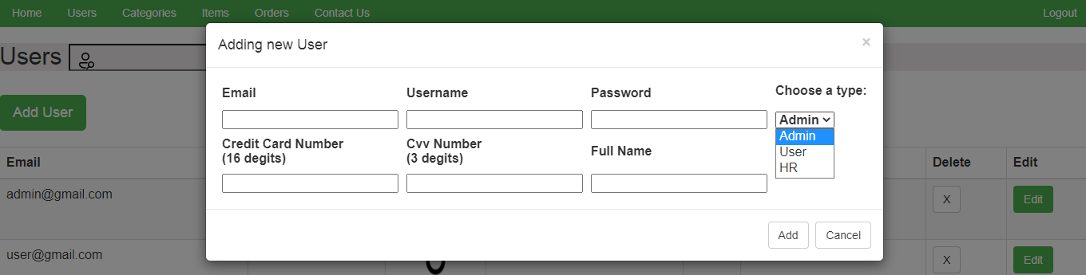

The admin now will be adding all the required information and choosing one of the three user types. When the add button is clicked the entered data will be checked in each field if it is correct, the password should meet the information security password policy. If the password does not match the information security password policy, when clicking the add button an error will be thrown as the following:

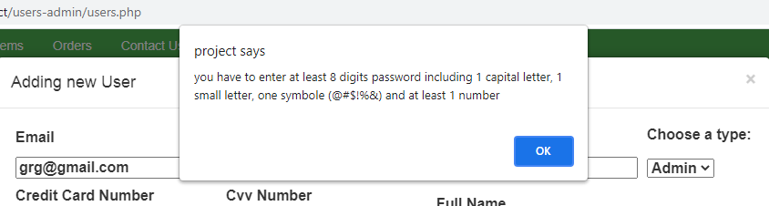

Then the credit card number which should be restrictively 16 numbers and the full name on the card then the CVV that should be restrictively 3 numbers if not the following error will be thrown:

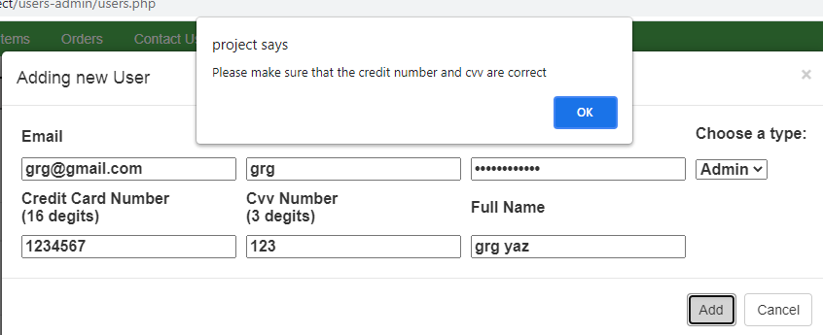

If a field is empty an error will be shown telling you to fill all the rows like the following:

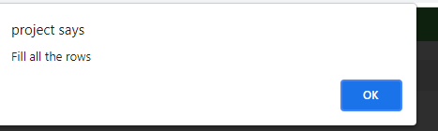

If the cancel button is clicked nothing will be added and the modal will close.

* Delete users with the delete button inside the users table

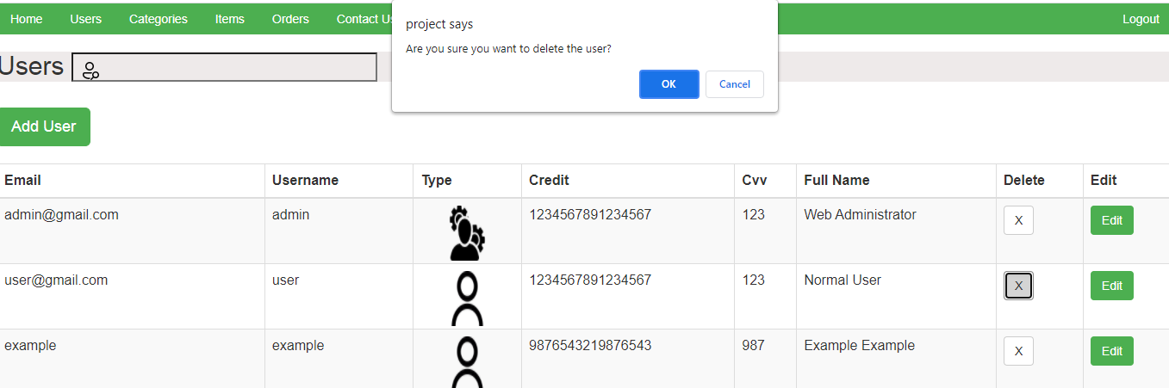

When the delete button is clicked the system will ask you that if you are sure that you want to delete that user. If ok is clicked, then the user will be immediately deleted from the database and the table will refresh. If cancel is clicked, nothing will change

* Edit users by clicking the edit button inside the table:

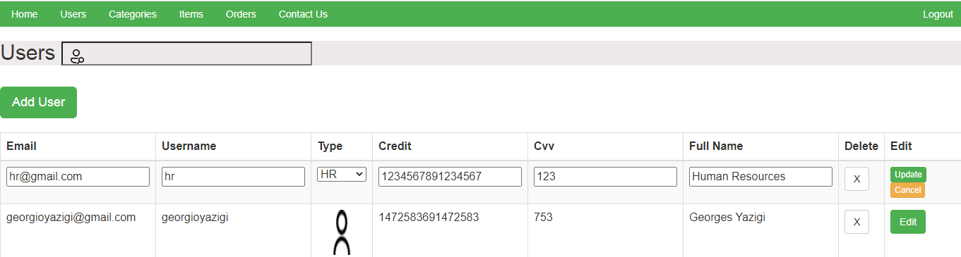

When edit button is clicked for a specific user the table row will be editable. The admin now can change all the user registered data except their password. Once the admin finishes editing a user the green update button will let him apply the changes that he made and he’ll be asked if he is is sure that he wants to edit this user like the following message:

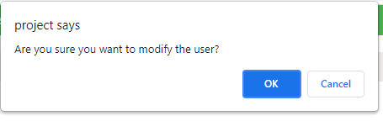

If ok is pressed the changes will be made and the data will be updated in the database and the table will immediately refresh and shows you the updated data.

If a field is empty an error will be shown telling you to fill all the rows like the following:



If cancel is pressed, then nothing will change and the recent updates that the admin have made will not be done.

To close the edit for a row, the admin should use the cancel orange button under the update green button, and nothing will be edited.

Categories page:

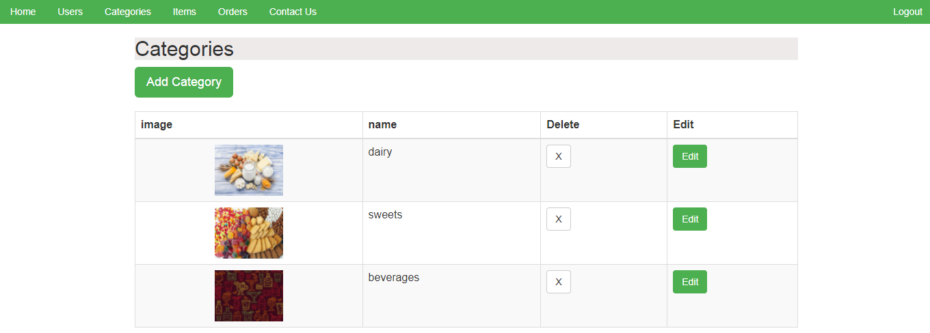

* In the categories page the admin can:
* Add categories by pressing the add category button

A modal for adding a category will appear:

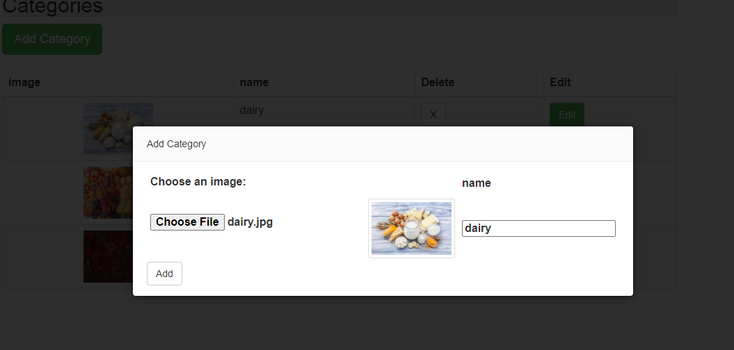

The admin now chooses an image (the image should be a gif /png /jpg /jpeg) from his files and add for it a name then by clicking add a new category will be added to the database and the table will refresh showing the new category that he has added

If a field is empty an error will be shown telling you to fill all the rows like the following:



* Edit category by clicking the edit button inside the table which will allow him to pick another image if he wants and to change the name if he would like to

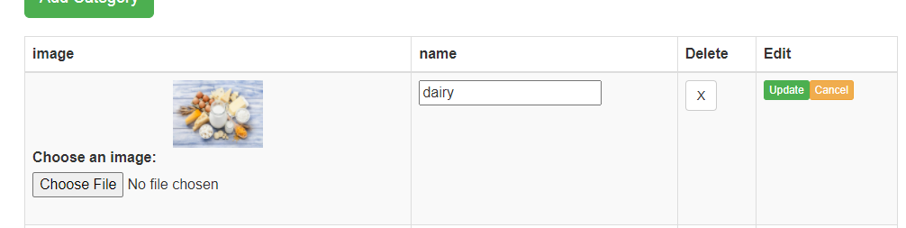

After the desired changes is made the update button will make an alert appear asking the admin if he is sure that he wants to modify this category

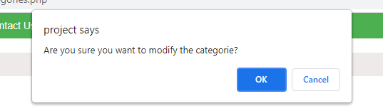

If ok is clicked the updates will be applied to the database and the table will refresh showing the new updates

If cancel is pressed, then nothing will change and the recent updates that the admin have made will not be done.

To close the edit for a row, the admin should use the cancel orange button next to the update green button, and nothing will be edited.

* Delete a category with the delete button inside the categories table

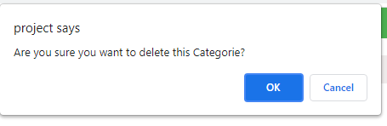

When the delete button is clicked the system will ask you that if you are sure that you want to delete that category. If ok is clicked, then the category will be immediately deleted from the database and the table will refresh. If cancel is clicked, nothing will change

Items page:

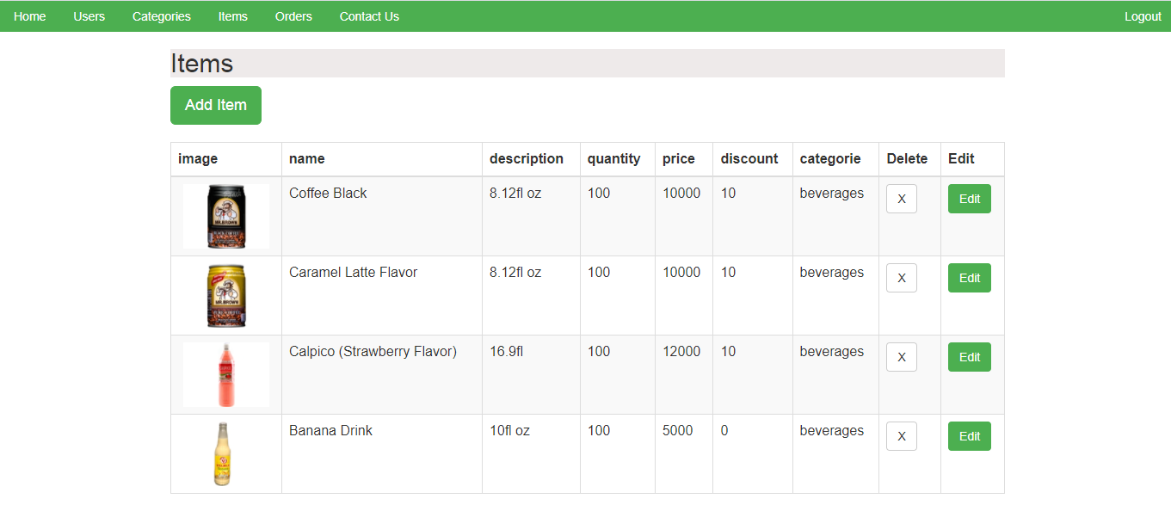

* In the items page the admin can:
* Add items by clicking the add item button:

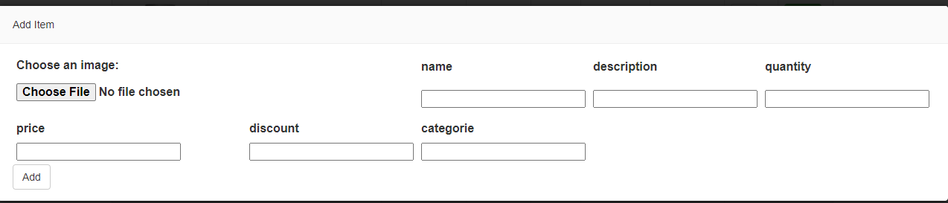

The admin has to choose an image (the image should be a gif /png /jpg /jpeg) from his files, then add the name, description of the item, quantity, price of the item, the discount on the item if there is a discount and the category name that he wants to add this item to.

If he clicks add, the new item will be added to the database and the table of items will refresh.

If a field is empty an error will be shown telling you to fill all the rows like the following:



* Edit Item by pressing the edit button inside the table which will allow him to pick another image if he wants and to change the name, description, quantity, price, discount, category name if he would like to

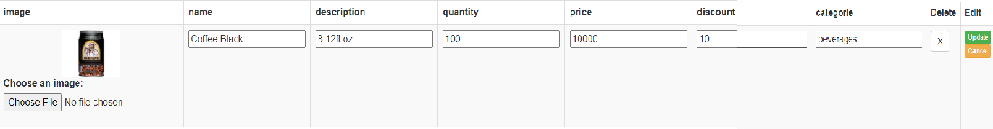

After the desired changes is made the update button will make an alert appear asking the admin if he is sure that he wants to modify this item.

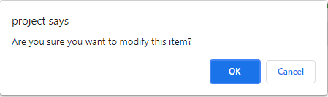

If ok is clicked the updates will be applied to the database and the table will refresh showing the new updates

If cancel is pressed, then nothing will change and the recent updates that the admin have made will not be done.

To close the edit for a row, the admin should use the cancel orange button under the update green button, and nothing will be edited.

* Delete an item with the delete button inside the items table

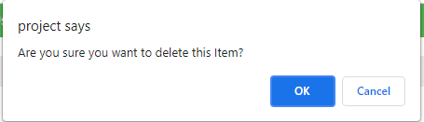

When the delete button is clicked the system will ask you that if you are sure that you want to delete this item. If ok is clicked, then the item will be immediately deleted from the database and the table will refresh. If cancel is clicked, nothing will change.

If the user type that logged in is an **HR** then the HR home page will appear where he can browse through the navigation the following pages:

and

Users page:

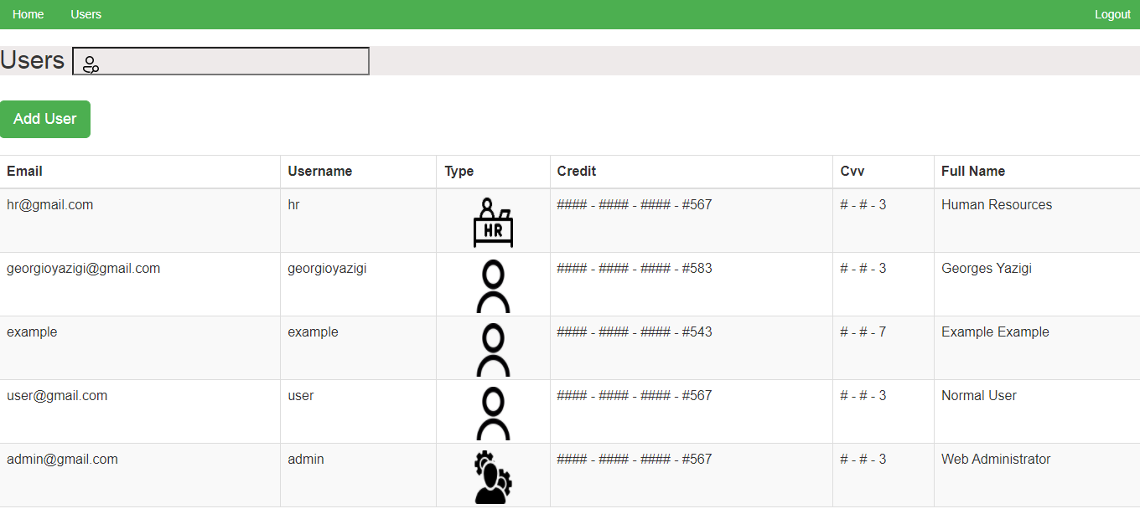

The HR is only allowed to add users and the table shows the HR hashed credit card and cvv number

By clicking the add user the HR is only allowed to add another HR or a user.

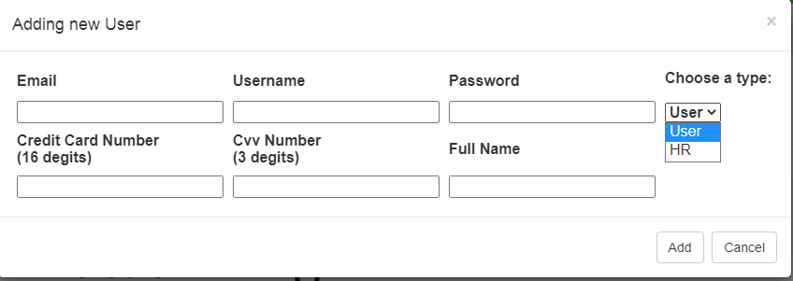

The HR now will be adding all the required information and choosing one of the two user types. When the add button is clicked the entered data will be checked in each field if it is correct, the password should meet the information security password policy. If the password does not match the information security password policy, when clicking the add button an error will be thrown as the following:

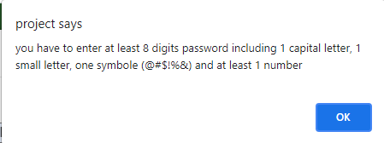

Then the credit card number which should be restrictively 16 numbers and the full name on the card then the CVV that should be restrictively 3 numbers if not the following error will be thrown:

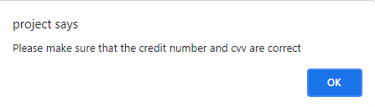

If a field is empty an error will be shown telling you to fill all the rows like the following:



If the cancel button is clicked nothing will be added and the modal will close.

If the user type that logged in is a user then the user home page will appear where he can browse through the navigation the following pages:

and

Categories page:

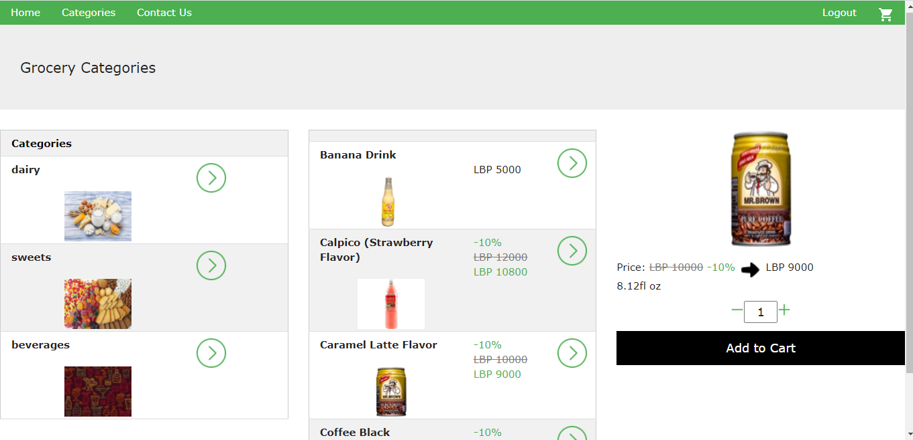

The user is able to go to the categories page and find a specific item inside a category.

The user can increase and decrease the quantity of a specific item that he wants to add to cart

By clicking the Add to Cart button, the user will be notified that the item was added



Basket page:

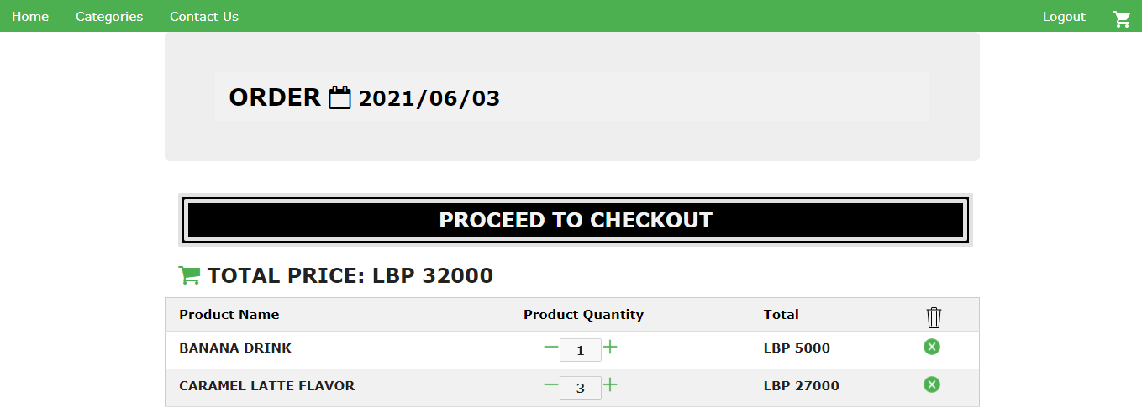

Inside this page the user is able to see his unfinished order and modify it threw the following:

Editing a single product quantity by pressing on the + and – signs which will automatically update the total price of the product

Deleting a single product by pressing the x sign inside the product row and this will make the system ask if he is sure that he wants to delete this product from the order as the following:

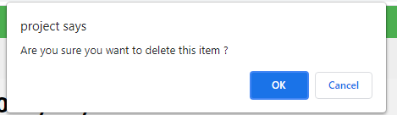

If ok is pressed, then the product will be removed from the order

If cancel is pressed, nothing will change

When the user hover the mouse over the Proceed to Checkout button the Total of his order will appear

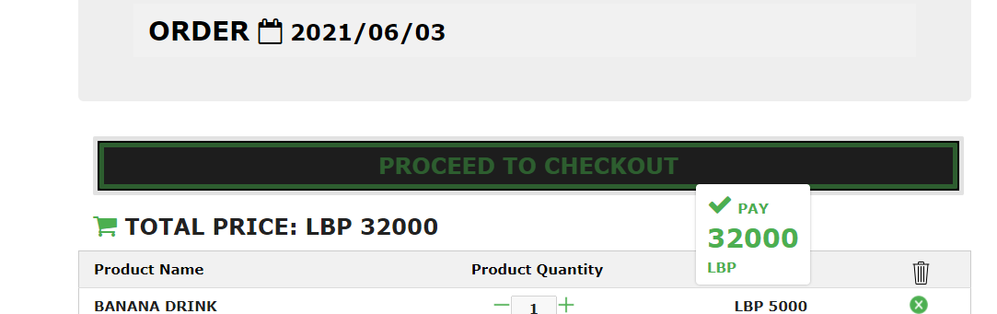

By clicking the proceed to checkout button the user will be asked if he is sure, if yes the current order will be payed and a new empty order will be created automatically for him.

